Expt-4

Create UDF (User Defined Functions) in Apache Pig and execute it in MapReduce / HDFS mode

AIM:

To create UDF in Apache Pig and execute it in MapReduce/HDFS mode.

Procedure:

Step 1: Install and Configure Apache Pig

1. **Download Apache Pig**:

Download the latest version of Pig from the official website:

wget https://dlcdn.apache.org/pig/pig-0.16.0/pig-0.16.0.tar.gz

1. **Extract Pig**:

tar xvzf pig-0.16.0.tar.gz

1. **Move Pig Directory**:

Move the extracted Pig files to a dedicated folder:

sudo mv pig-0.16.0 /usr/local/pig

1. **Set Environment Variables**:

Edit the .bashrc file to set up Pig environment variables:

nano ~/.bashrc

Append the following lines:

export PIG_HOME=/usr/local/pig export PATH=$PATH:$PIG_HOME/bin

export PIG_CLASSPATH=$HADOOP_HOME/conf

Apply the changes:

source ~/.bashrc

1. **Verify Pig Installation**:

Run the following command to verify if Pig has been installed correctly:

pig -version

Step 2: Create Sample Data for the Pig Job

1. **Create a Sample Data File**: Create a sample text file (sample.txt) with some dummy data:

nano sample.txt

Add the following content:

1,John 2,Jane 3,Joe 4,Emma

1. **Upload the Data File to HDFS**: Upload the sample file to Hadoop's distributed file system (HDFS):

hdfs dfs -mkdir /piginput

hdfs dfs -put sample.txt /piginput

Step 3: Write Pig Script for the UDF

1. Create the Pig Script:

Create a new Pig script (demo_pig.pig):

nano demo_pig.pig

Write the following code in the script to load and display the data: pig

-- Load data from HDFS

data = LOAD '/piginput/sample.txt' USING PigStorage(',') AS (id:int, name:chararray);

-- Display the loaded data

DUMP data;

Step 4: Write the UDF in Python

1. **Create the Python UDF**:

Create a Python file (uppercase_udf.py) to convert text to uppercase:

nano uppercase_udf.py

def uppercase(text): return text.upper()

if name == " main ": import sys

for line in sys.stdin: line = line.strip()

print(uppercase(line))

1. **Upload the Python UDF to HDFS**: **Upload the UDF to HDFS:**

hdfs dfs -mkdir /udfs

hdfs dfs -put uppercase_udf.py /udfs

Step 5: Update Pig Script to Use UDF

1. Modify the Pig Script to Include UDF:

Edit the demo_pig.pig script to register the UDF and process the data:

nano demo_pig.pig

Modify the script as follows:

pig

-- Register the Python UDF script

REGISTER '/udfs/uppercase_udf.py' USING jython AS myudf;

-- Load data from HDFS

data = LOAD '/piginput/sample.txt' USING PigStorage(',') AS (id:int, name:chararray)

-- Apply UDF to convert names to uppercase

uppercased_data = FOREACH data GENERATE myudf.uppercase(name);

-- Display the transformed data

DUMP uppercased_data;

Step 6: Run the Pig Script

1. **Run the Pig Script**:

Run the Pig script using the following command:

pig -x mapreduce demo_pig.pig

1. **View Output**

hdfs dfs -cat /pigoutput/part-m-00000

OUTPUT:

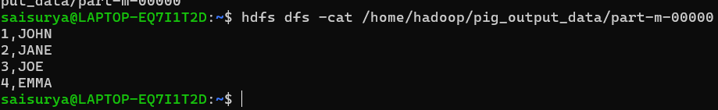

RESULT:

Thus, UDF in Apache Pig has been created and executed in MapReduce/HDFS mode successfully.